# Import an OData Module into a Mendix Project

This document describes the steps required to prepare a Mendix project to use OData services from an SAP system.

## SAP OData Connector

Using OData services from SAP systems is a complex process. To facilitate the process, Mendix provides an add on called the SAP OData Connector. The SAP OData Connector provides several SAP OData specific microflow activities as well as other artifacts. The add on is automatically included in the project if you use a SAP template to create a project. You can also add it from the App Store.

You can find add ons in the Project Explorer in the App Store modules folder.

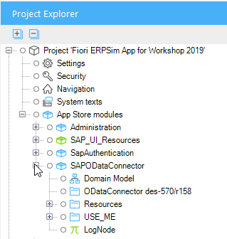

## SAP OData Model Creator

When you retrieve data from a external system into a Mendix app you must have a place to store it in the project. Mendix apps use the Domain Model to define the required data structures. SAP OData services can have quite complex data models and it would difficult to create everything required manually. To facilitate this process, Mendix provides a tool called the SAP OData Model Creator. The tool takes the metadata of an OData service and generates a Mendix module which you can import into a Mendix project.

### Create the Mendix Module

You can access the SAP OData Model Creator at the following URL:

<https://appstore.home.mendix.com/link/app/105622/>

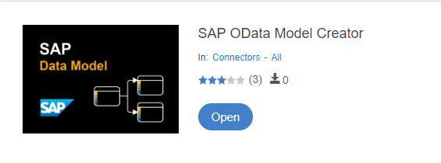

The model creator needs the metadata of the OData services to generate the module. The metadata documents the services and data available from the OData service. The metadata can be obtained by adding $metadata to the end of the OData service document URL. The URL below shows the URL to obtain the metadata for a service on an S/4 HANA system called SD_F1814_SO_FS_SRV, a service that provides data on sales orders. The example below uses this service.

To obtain the metadata, login to the Fiori launchpad with your S/4 HANA credentials (so the browser has your authentication information) then open a new tab in the browser and navigate to this URL (replace <HOST> with the host name for your server):

http://<HOST> /sap/opu/odata/sap/SD_F1814_SO_FS_SRV/$metadata/

Save the metadata to a file (ctrl-s) or use the provided metadata file.

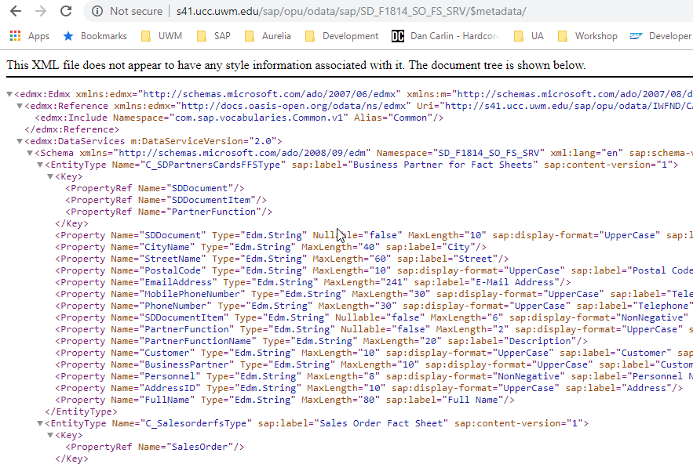

In the SAP OData Model Creator, click Open then click Manual:

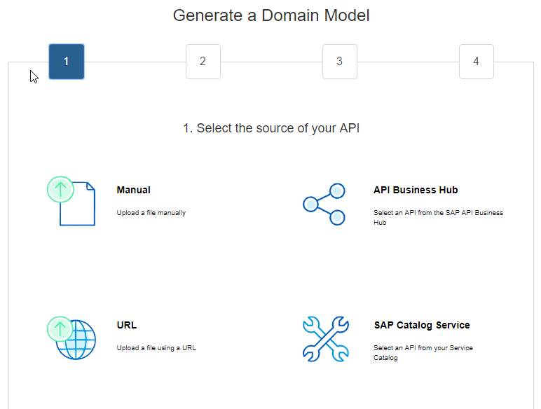

Open the metadata file and click Continue.

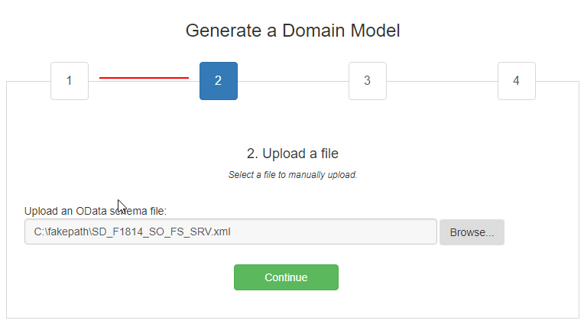

Select SD_F1814_SO_FS_SRV and click Continue.

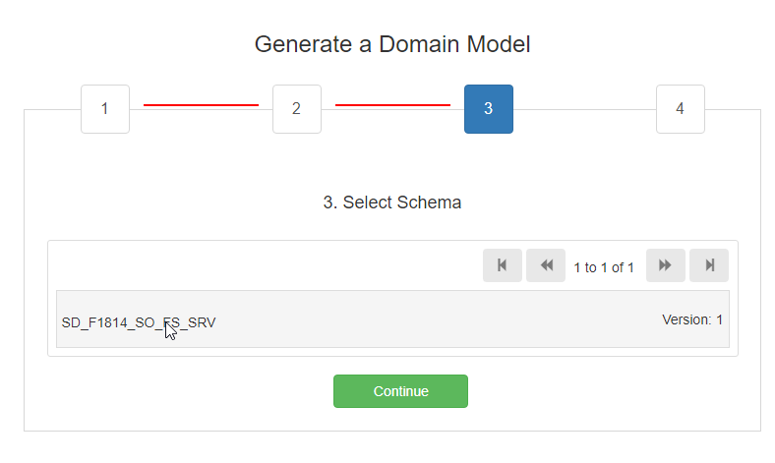

Click Generate .mpk and when it has finished click Download.

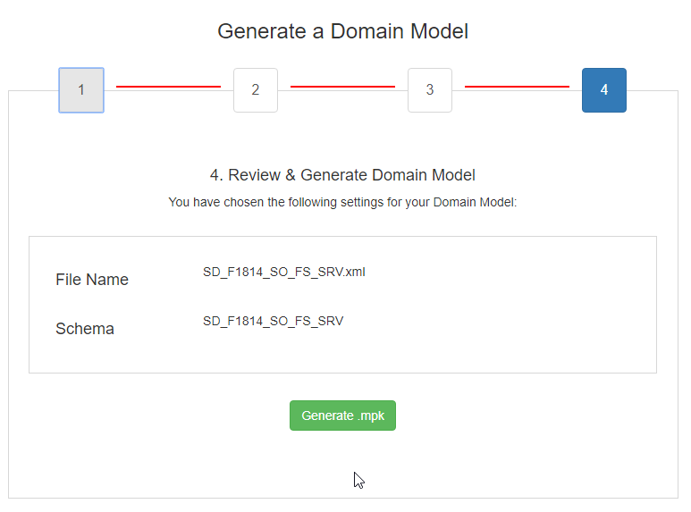

When the module has been generated, click Download.

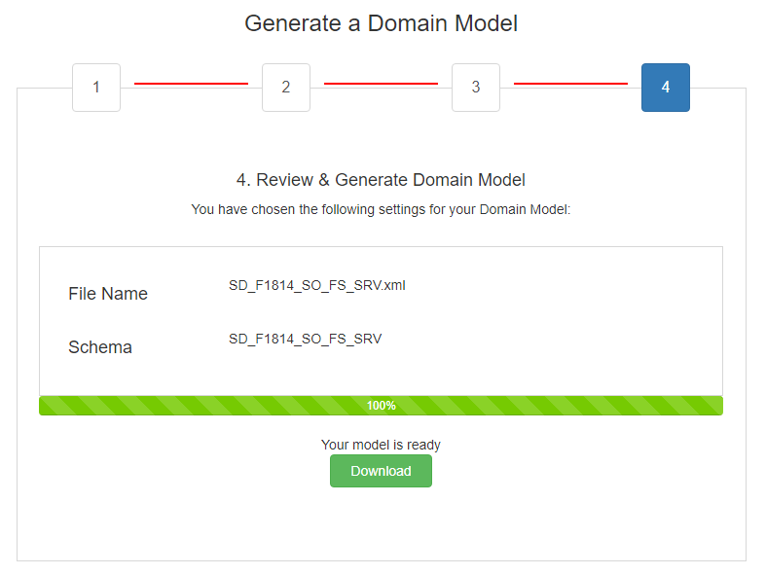

### Import the Module into the Project

In the Mendix Modeler, right-click the project name in the Project Explorer and click Import module package…

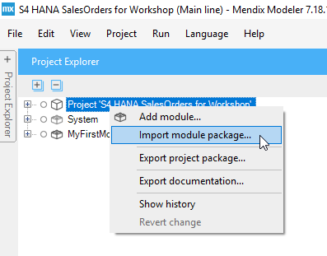

Navigate to the module package you downloaded and select it. When prompted, select to add it as a new module.

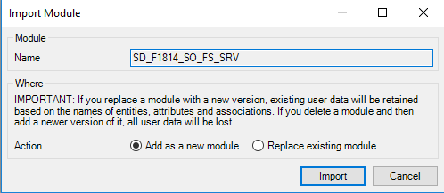

The module is added to the project.

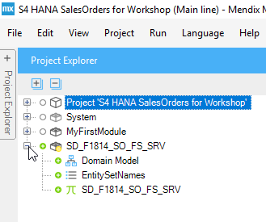

The Domain Model shows the database entities described by the metadata.

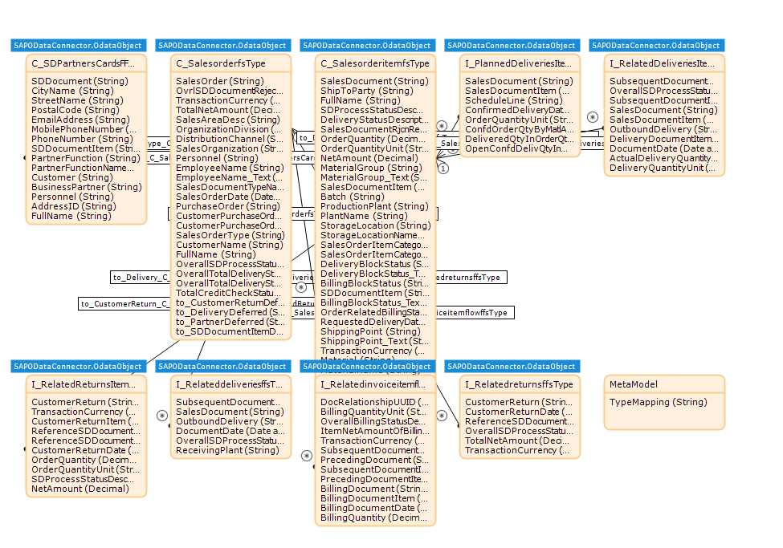

EntitySetNames is an enumeration of the service endpoints available in the OData model.

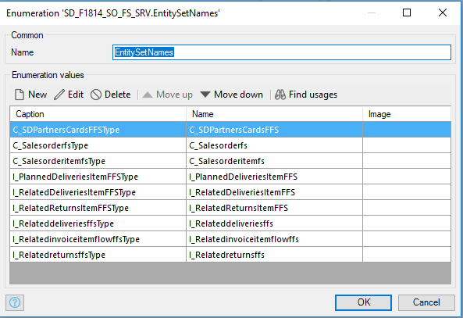

SD_F1814_SO_FS_SRV is a constant set to the base URI of the OData service.

